40218-499

UNITED STATES AIR FORCE
DISTRIBUTED COMMON GROUND STATION (AF DCGS)
ADVANCED PROCESSING SYSTEM PLUS (APS+)

OPERATION AND MAINTENANCE MANUAL

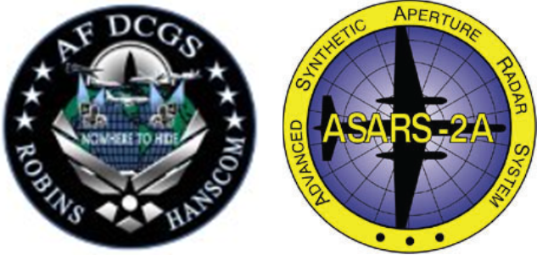

DISTRIBUTION STATEMENT E: Distribution authorized to DoD components only (Critical Technology and Direct Military Support), (01 March 2018). Other requests for this document shall be referred to AF DCGS Data Management Office, AFMC AFLMC/HBGB, 235 Byron St., Suite 19A, Robins AFB, GA 31098-1670.

WARNING - This This document contains technical data whose export is restricted by the Arms Export Control Act(Title 22, U.S.C., Sec 2751, et. seq.) or the Export Administration Act of 1979, as amended, Title 50, U.S.C.,App. 2401 et. seq. Violations of these export laws are subject to severe criminal penalties. Disseminate in accordance with provisions of DoD Directive 5230.25.

HANDLING AND DESTRUCTION NOTICE – Comply with distribution statement and destroy by any method that will prevent disclosure of contents or reconstruction of the document.

Contract Number: FA8528-14-D-0023

Raytheon
Space and Airborne Systems Division
2000 E. El Segundo Boulevard
El Segundo, CA 900245

15 FEBRUARY 2020

Table of Content
1 GENERAL INFORMATION 1
1.1 Overview 1
1.1.1 Scope 1
1.1.2 Abbreviations and Acronyms 2
1.1.3 Referenced Documents 2
1.2 System Description 3
1.2.1 Operating Sites 3
1.2.2 Configurations 4
1.2.3 Multiple Datalink Capabilities 6
1.2.4 Mission Threads 7
1.2.5 APS+ Description 9
1.2.6 APS+ Concept of Operations 11
2 OPERATOR INSTRUCTIONS 12
2.1 MCI Operator Instructions 12
2.1.1 MCI Displays and Controls 12
2.1.2 MCI Startup and Shutdown 13
2.1.3 MCI Operation 18
2.1.4 Mission Thread Operation 20

LIST OF FIGURES

Figure 1 Direct LOS Configuration 4
Figure 2 Reach Configuration 5
Figure 3 BLOS Configuration 6
Figure 4 Multiple Datalink Capabilities 7
Figure 5 ASARS-2A Data from Reach Site to Core Site (To be updated…) 8
Figure 6 ASARS-2A from RGS to Core Site (To be updated…) 9
Figure 7 APS+ External Interfaces (To be updated…) 10
Figure 8 Launch Button 14
Figure 9 Applications Menu 14
Figure 10 Mission Configuration Interface 15
Figure 11 Mission Configuration - Start New 15
Figure 12 ASARS-2A - Start Mission 16
Figure 13 ASARS-2A - Start Mission (To be updated…) 17
Figure 14 Core Site - Mission Status 17
Figure 15 Reach Site - Mission Status 18
Figure 16 MCI Operation - Core Site 18
Figure 17 MCI Operation - Reach Site 20
Figure 18 SCWS General User Options 21
Figure 19 SCWS Options Keymap 21
Figure 20 SCWS Options Appearance - Documents Tab 22
Figure 21 SCWS Options Appearance - Windows 22
Figure 22 SCWS Options Appearance Look and Feel 23
Figure 23 SCWS Options Miscellaneous Files 23
Figure 24 SCWS Options Miscellaneous Output 24
Figure 25 SCWS Options Miscellaneous References Tab 24
Figure 26 SCWS Annotation, AUX Data, and Ground Station Message Windows 25
Figure 27 CBIT Status 26
Figure 28 CBIT ESA Temperatures 26
Figure 29 CBIT Chassis Control Module 26
Figure 30 CBIT Detection Error 27
Figure 31 ASARS Mission Tools - SCWS 27
Figure 32 ASARS Mission Tools - SCWS (Reach) 28
Figure 33 APP Configuration (SCWS) 28
Figure 34 ASARS - 2A SCWS Mode 28
Figure 35 Modes Menu – Processing 29
Figure 36 Mission Definition 29
Figure 37 SCWS Monitor 30
Figure 38 SCWS Exit Dialog 31
Figure 39 SCWS Open File Dialog 31
Figure 40 SCWS Connect Dialog 31
Figure 41 OVR – Scale Image 32
Figure 42 OVR – Brightness and Contrast 32
Figure 43 OVR – North Arrow 32
Figure 44 OVR – Center Corral 33
Figure 45 OVR – Image Orientation 33
Figure 46 OVR – Image Histogram 34
Figure 47 OVR Freeze Image 34
Figure 48 OVR Clear Image 34
Figure 49 HRD – Scale Image 34
Figure 50 HRD Image Brightness and Contrast 35
Figure 51 HRD – North Arrow 35
Figure 52 HRD – Image Orientation 36
Figure 53 HRD – Image Histogram 36
Figure 54 SCWS System Control Mission Definition 37
Figure 55 SCWS System Control Mission Definition ID Dialog 37
Figure 56 SCWS Uplink OBP Start/Stop Processing 38
Figure 57 SCWS Uplink Processing Toggle 38
Figure 58 SCWS Uplink OBP Start/Stop Collection 39
Figure 59 SCWS Uplink OBP Start/Stop Collection Toggle 39
Figure 60 SCWS Uplink OBP Remap CE 40
Figure 61 SCWS Uplink OBP Remap CE Dialog 41
Figure 62 SCWS Uplink OBP Reinitialize OBP 42
Figure 63 SCWS Uplink OBP Reinitialize OBP Dialog 42
Figure 64 SCWS Uplink OBP Record ARS Messages 43
Figure 65 SCWS Uplink OBP Record ARS Messages Dialog 43
Figure 66 SCWS Uplink OBP Spot Apodization 44
Figure 67 SCWS Uplink OBP Spot Apodization Dialog 44
Figure 68 SCWS Uplink OBP Request Processing Options 45
Figure 69 SCWS Uplink OBP Request Processing Options Dialog 45
Figure 70 SCWS Uplink OBP Terminate 46
Figure 71 SCWS Uplink OBP Terminate Dialog 46
Figure 72 SCWS Uplink OBP Request ARS Logs 47
Figure 73 SCWS Uplink OBP Request ARS Logs Dialog 47
Figure 74 SCWS Uplink OBP Request Test Image 48
Figure 75 SCWS Uplink OBP Request Test Image Dialog 48
Figure 76 SCWS Uplink OBP Set Serial Numbers 49
Figure 77 SCWS Uplink OBP Set Serial Numbers Dialog 49
Figure 78 SCWS Uplink MSU 51
Figure 79 SCWS Airborne Mass Storage Unit 51
Figure 80 SCWS Airborne Mass Storage Unit Confirmation Dialog 51
Figure 81 SCWS Airborne MSU Playback 51
Figure 82 SCWS Airborne MSU Position Dialog 52
Figure 83 SCWS MSU Record Dialog 52
Figure 84 SCWS MSU Rewind Confirmation 53
Figure 85 SCWS MSU Request Directory Dialog 53
Figure 86 SCWS MSU - Closing the MSU Window 53
Figure 87 SCWS Uplink REC Scene Abort 54
Figure 88 SCWS Uplink REC Scene Abort Dialog 54
Figure 89 SCWS Uplink REC Test Target 55
Figure 90 SCWS Uplink REC Test Target Dialog 56
Figure 91 SCWS Uplink REC Boresight Adjust 61
Figure 92 SCWS Uplink REC Boresight Adjust Dialog 61
Figure 93 SCWS Uplink REC - REC Reset 62
Figure 94 SCWS Uplink REC - REC Reset Dialog 62
Figure 95 SCWS Uplink REC - REC VME Reset 63
Figure 96 SCWS Uplink REC - REC VME Reset Dialog 63
Figure 97 SCWS Uplink REC ARS Data Request 64
Figure 98 SCWS Uplink REC ARS Data Request Dialog 64
Figure 99 SCWS Uplink REC CDU Reset 65
Figure 100 SCWS Uplink REC CDU Reset Dialog 65
Figure 101 SCWS Uplink REC CDU Reset List 66
Figure 102 SCWS Uplink REC FCD Downlink Rate 68
Figure 103 SCWS Uplink REC FCD Downlink Rate Dialog 69
Figure 104 SCWS Uplink - Uplink Cancel 69
Figure 105 SCWS Uplink - Uplink Cancel Dialog 70

LIST OF TaBLES

Table 1 Abbreviations and Acronyms 2
Table 2 Referenced Documents 2
Table 3 Operating Sites 3
Table 4 Exploitation Segment Options (To be updated…) 19
Table 5 OBP Commonly Used Commands 50
Table 6 Array Modes 58
Table 7 CDU Reset (a) 67
Table 8 Change Detection 95
Table 9 CDU Reset Information 108

GENERAL INFORMATION

Overview
This Operation and Maintenance (O&M) Manual provides information and instructions on how to operate and maintain the United States Air Force Distributed Ground Station (AF DCGS) Advanced Processing System Plus (APS+) software.

The intended audience for this manual are U-2S Dragonlady aircraft / Advanced Synthetic Aperture Radar System-2A (ASARS-2A) high-resolution, multimode, long-range, air-to-ground radar sensor Mission Planners (MPs) and Direct Mission Support Maintenance Personnel (DMSMP) using APS+ installed in AF DCGS equipment located at operational Distributed Ground Sites (DGS) and Raytheon ASARS-2A engineers supporting in-plant maintenance and sustainment activities. This manual assumes the user already has working knowledge of the ASARS-2A sensor, server, workstation operating systems and graphical user interfaces (GUIs), and related computer networking. It is not meant to serve as a complete reference for all mission activities supported by MPs and DMSMP.

The APS+ software modernizes the legacy APS software used operationally for over 20 years. This modernization was accomplished to align with AF DCGS technology roadmaps and to make the APS+ software more technically compatible, functionally robust, and easier to maintain.

APS+ displays ASARS-2A sensor health, status, and image quality and is used for U-2S / ASARS-2A mission planning.

APS+ software is installed in the Distributed Common Ground Station (DCGS) System Integration Lab (DSIL), East Coast Hub (ECH), and West Coast Hub (WCH). APS+ is capable of supporting multiple instances, allowing APS+ to be remotely accessible by the deployed DGS sites.

The APS+ software is capable of being customized at each operating site to accommodate differences in configuration, interfaces, or mission needs. Workstations in each AF DCGS may provide slightly different shortcuts to launch certain APS+ applications. This manual does not cover site-specific APS+ customizations.

Scope
Type of manual: Operation and Maintenance Manual
End item nomenclature: United States Air Force (AF) Distributed Common Ground Station (DCGS) Advanced Processing System Plus (APS+) Software
End item purpose: Display ASARS-2A sensor health, status, and image quality and provide U-2S aircraft / ASARS-2A sensor mission planning for Intelligence, Reconnaissance, and Surveillance (ISR) mission operations.
Manual Use: To provide AF DCGS APS+ software operation and maintenance information and instructions. The information and instructions include APS+ general information, operator instructions, maintenance instructions, and supporting information.
Figures and Tables: Figures and tables are numbered and titled. The figures and tables are sequentially numbered within the subsection.

Abbreviations and Acronyms
The list of abbreviations and acronyms is provided in Table 1. Electronically displayed, placarded, and referenced document title abbreviations are presented throughout this manual as they appear and may not be included in Table 1. Abbreviations and acronyms with classified definitions are not defined in this publication. To be updated…
Table 1 Abbreviations and Acronyms
Acronym | Definition
AF DCGS | Air Force Distributed Common Ground Station (AF DCGS)
APS+ | Advanced Processing System Plus
ASARS-2A | Advanced Synthetic Aperture Radar System-2A
CSP | Common Sensor Planner
DCGS | Distributed Common Ground System
DGS | Distributed Ground Station
DMSMP | Direct Mission Support Maintenance Personnel
DSIL | Distributed Common Ground Station (DCGS) System Integration Lab
ECH | East Coast Hub
GUI | Graphical User Interface
ISR | Intelligence, Reconnaissance, and Surveillance
MCI | Mission Configuration Interface
MP | Mission Planner
O&M | Operation and Maintenance
SCWS | Sensor Control Work Station
WCH | West Coast Hub
… | …

Referenced Documents
Documents referenced in this manual are listed in Table 2. Reference Documents. Use the latest version of documents applicable to the APS+ Program. Sample information. To be updated…
Table 2 Referenced Documents
Document Number | Title
1234567 | Commercial Manual
MIL-SPEC-56789 | Military Specification
9876543-210 | Engineering Drawing
… | …

System Description
At established AF DCGS sites and Distributed Ground Station (DGS) deployed locations, operators plan navigational routes for the U-2S aircraft to follow during the mission. Using the planned navigational routes, operators can then perform mission planning by identifying potential targets for imagery collection planning and scene planning to capture a target’s imagery using one of the ASARS-2A modes.
A completed mission plan is uplinked to the U-2S aircraft / ASARS-2A sensor airborne system for collection and processing. As the aircraft approaches a preplanned scene, raw data is collected as Video Phase History (VPH) data by the Receiver Exciter Controller (REC), and then transmitted to the On-Board Processor (OBP) for recording and/or processing.
Once the data is received by the OBP, data is captured and processed into imagery. Users have the option of recording imagery or raw VPH data onto the Sensor Storage Array (SSA). Any imagery which is created is dispatched to an AF DCGS, where analysts may evaluate it.
At any point during the mission, operators may edit the mission plan by planning additional scenes or altering parameters of previously planned scenes. Updated scenes may then be uplinked to re-task the ASARS-2A sensor. Scenes requiring immediate collection may also be uplinked to the ASARS-2A sensor for ad hoc tactical requirements.

Operating Sites
Each operating site is designated as a core site, reach site, or test site. Core sites and reach sites are mission sites, while test sites function like core sites but do not support operational missions. Reach sites have a line-of-site (LOS) link to the sensor and transmit imagery and telemetry to core sites via satellite. Core sites have the capability to process multiple concurrent missions independently.

Functions performed by the APS at core sites include mission planning, mission monitoring, sensor control, screening, dissemination, and exploitation. The following shows a list of sites and their site designation.

Table 3 Operating Sites
Site Name | Core Site | Reach Site | Test Site
DGS-1 | X
DGS-2 | X
DGS-3 | X
DGS-4 | X
DGS-5 | X
DGS-X |  |  | X
DGS-IN | X
DGS-KS | X
DGS-MA | X
DSIL |  |  | X
FOL |  | X
FTF |  |  | X

Configurations
There are three basic ground datalink configurations for receiving ASARS-2A mission data and transmitting commands and mission plan updates.
- Direct Line of Sight (LOS) configuration
- Reach configuration
- Beyond Line of Sight (BLOS) configuration

Direct LOS Configuration
In the Direct LOS configuration (Figure 1), the airborne system downlinks data directly to an AF DCGS site equipped with a compatible Common Data Link (CDL) receiving antenna. The AF DCGS can also uplink commands via CDL to the airborne system.
In a Direct LOS configuration, the AF DCGS site typically performs all of the sensor maintenance, sensor re-tasking, imagery screening, and ASARS-2A sensor imagery exploitation. The Flight Test Facility (FTF) and DGS-3 sites typically use a Direct LOS configuration.
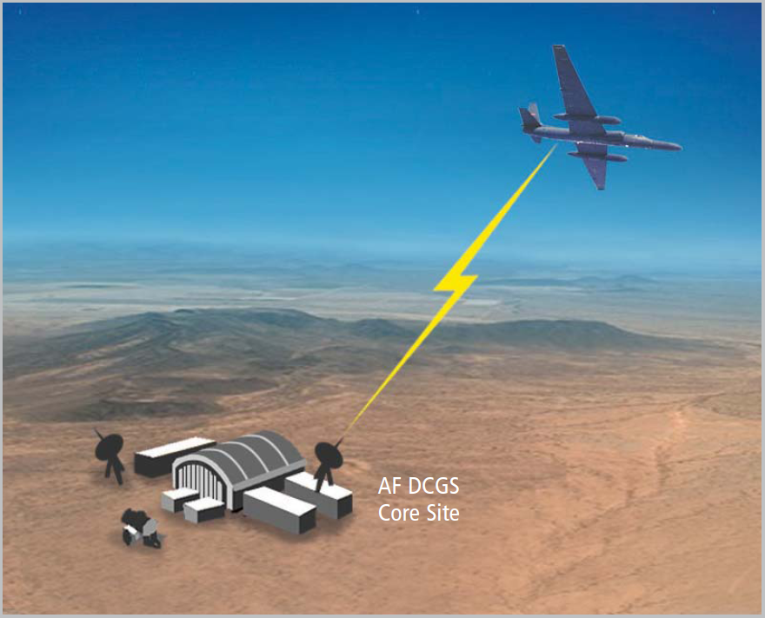
Figure 1 Direct LOS Configuration

Reach Configuration
In the Reach configuration (Figure 2), the airborne system downlinks data via CDL to a ground relay site located within the footprint of the airborne CDL antenna. The ground relay site then uses a satellite communications (SATCOM) link to relay the data to an AF DCGS site. ASARS-2A sensor commands can also be uplinked via the reverse path: from the AF DCGS site to the ground relay site via SATCOM link, then to the airborne sensor via CDL. The connection between a ground relay site and a particular AF DCGS site is point-to-point. A ground relay site can only connect to one AF DCGS site at a time.
In a Reach configuration, primary sensor control and monitoring is usually performed at the AF DCGS site. However, the ground relay site retains a capability to assert ASARS-2A sensor control if necessary. The Forward Operating Location (FOL) site uses a Reach configuration. Most AF DCGS sites are capable of using FOL as a reach site if dictated by mission needs.
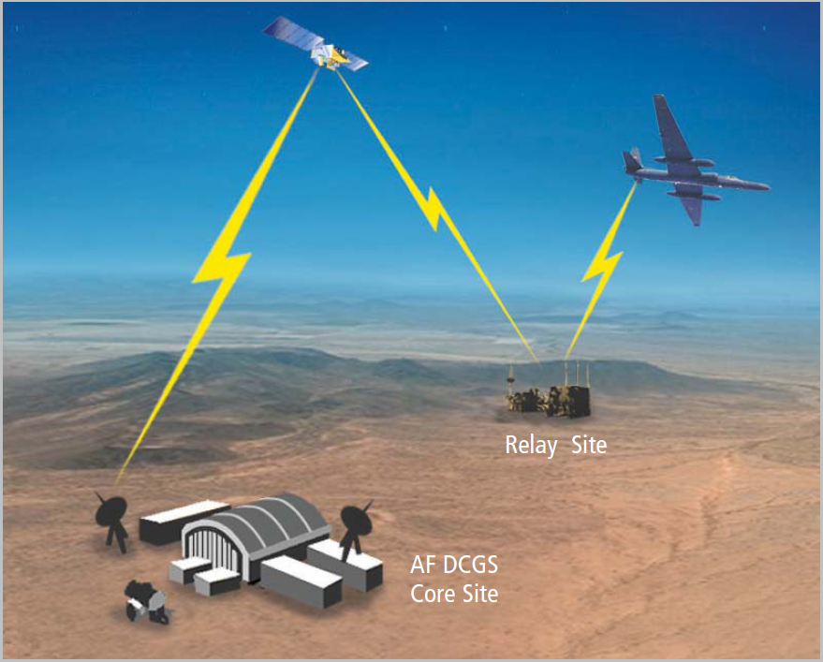
Figure 2 Reach Configuration

BLOS Configuration
In the BLOS configuration (Figure 3), the airborne system downlinks data and receives commands via another communications system on the U-2S aircraft which uses a different SATCOM architecture than a reach site. The receiving ground site for a BLOS SATCOM link is called a Relay Ground Station (RGS); there are currently two RGS sites (RGS-1 and RGS-2). Once received by an RGS site, the data is made available to one or more DGS sites via ground communication links. AF DCGS coordinates which DGS site is the lead for the mission (“prime”) and which other DGS sites will participate as federated mission partners. Although data may be disseminated from an RGS to multiple DGS sites, only one DGS site at a time is allowed to uplink commands to the sensor via the RGS.
In a BLOS configuration, primary sensor control is performed at a single DGS site; all sites receive sensor data and telemetry. Any DGS site is capable of supporting BLOS operations.

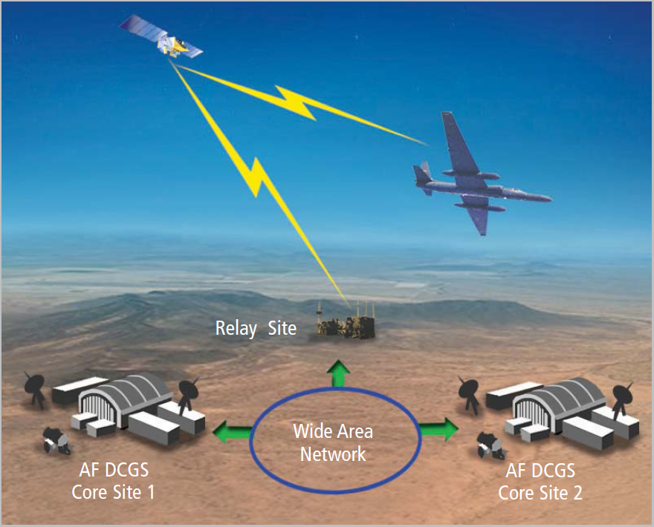
Figure 3 BLOS Configuration

Multiple Datalink Capabilities
The U-2S aircraft has multiple datalink capabilities (Figure 4). The U-2S aircraft can use two datalinks at the same time; either one CDL datalink and one BLOS SATCOM datalink or two different, independent, concurrent CDL datalinks.
If more than one datalink is active, the ASARS-2A sensor can only accept commands from one datalink. By default, the sensor will accept commands from the pilot selected primary datalink. A Control Data Unit (CDU) Reset command can be sent to instruct ASARS-2A sensor to accept commands from a specific datalink, regardless of the pilot selected primary datalink.
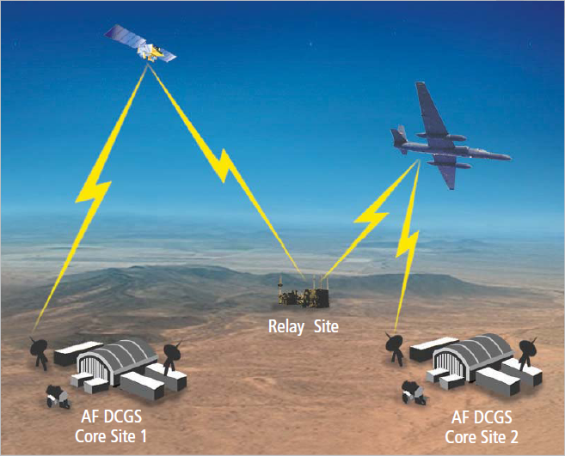
Figure 4 Multiple Datalink Capabilities

Mission Threads
Dual Mission refers to two U-2S aircraft simultaneously flying separate missions. An AF DCGS site is capable of supporting Dual Mission simultaneous mission threads. Each mission thread receives data only from the designated source of mission thread. To be updated…

ASARS-2A Data from Reach Site to Core Site
This scenario occurs only if an AF DCGS core site has a Direct LOS link to the ASARS-2A sensor (Figure 5). The AF DCGS site VIP-C receives ASARS-2A sensor files and sends to the image server. Processes on the image server connect to the VIP-C to receive telemetry and VIP-C status. Uplink commands are passed from the image server through the VIP-C to the ASARS-2A sensor. To be updated…
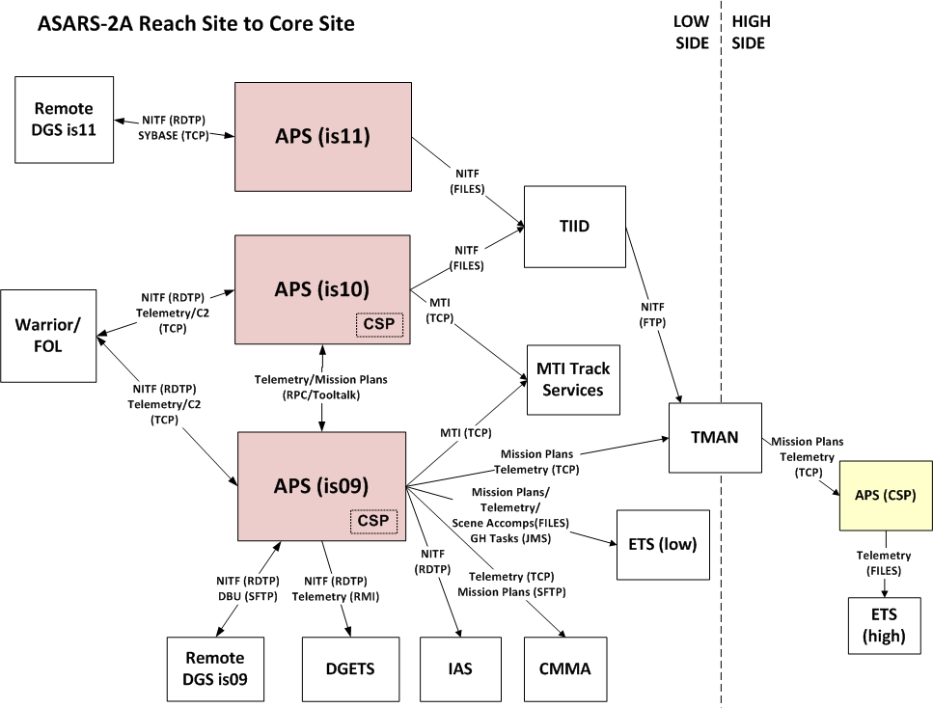
Figure 5 ASARS-2A Data from Reach Site to Core Site (To be updated…)

ASARS-2A Data from RGS to Core Site
This scenario occurs if an AF DCGS core site receives and displays imagery, MTI data and telemetry transmitted from the reach site (Figure 6). The AF DCGS core site sends uplink commands to the reach site. To be updated…
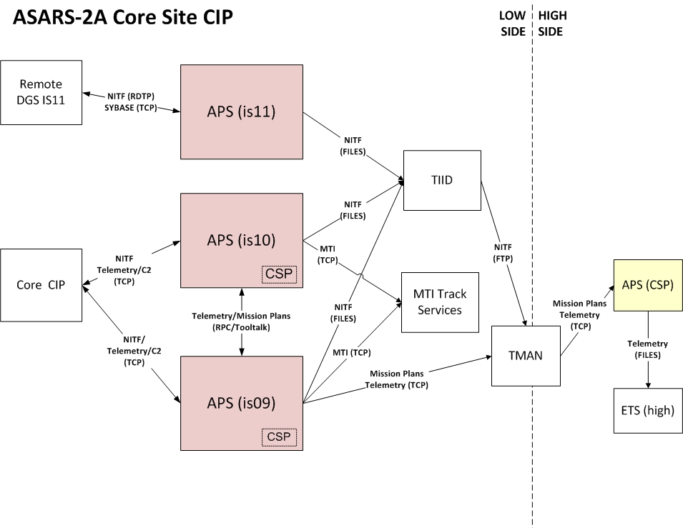
Figure 6 ASARS-2A from RGS to Core Site (To be updated…)

APS+ Description
The APS+ software provides ASARS-2A sensor health and status monitoring, sensor collection planning, sensor command and control, and sensor imagery screening capabilities. APS+ software is installed on Open Architecture Distributed Common Ground Station (OA DCGS) system, integrated with enterprise services and mission capabilities at central hub sites and is remotely accessed by operational users at individual DGS sites.

APS+ Software Environment
APS+ is a software component which will be deployed as part of the OA DCGS subsystem within the AF DCGS enterprise. APS+ belongs to the imagery intelligence (IMINT) segment. APS+ operates within a virtual machine (VM) hosted on the OA DCGS hardware stack at operational hub sites. APS+ user-facing applications are made available to users at Distributed Ground Station (DGS) sites which are logically and often physically separated from the hub locations.
Similar to other OA DCGS components, APS+ interfaces with standard enterprise services which provide functions such as identity management, access control, auditing, intrusion detection, time of day, hardware and software health and status monitoring, asset management, and other capabilities. Interfaces to standard enterprise services are primarily related to the management of the AF DCGS enterprise, not specifically related to functional interfaces required for mission execution.

APS+ Interfaces
The APS+ internal and external interfaces both have input and output functions (Figure 7). APS+ internal interfaces are defined as APS+ software in one context interfacing to APS+ software in another context. APS+ external interfaces are defined as APS+ software interfacing to anything which is not APS+ software. Additional details to be provided…
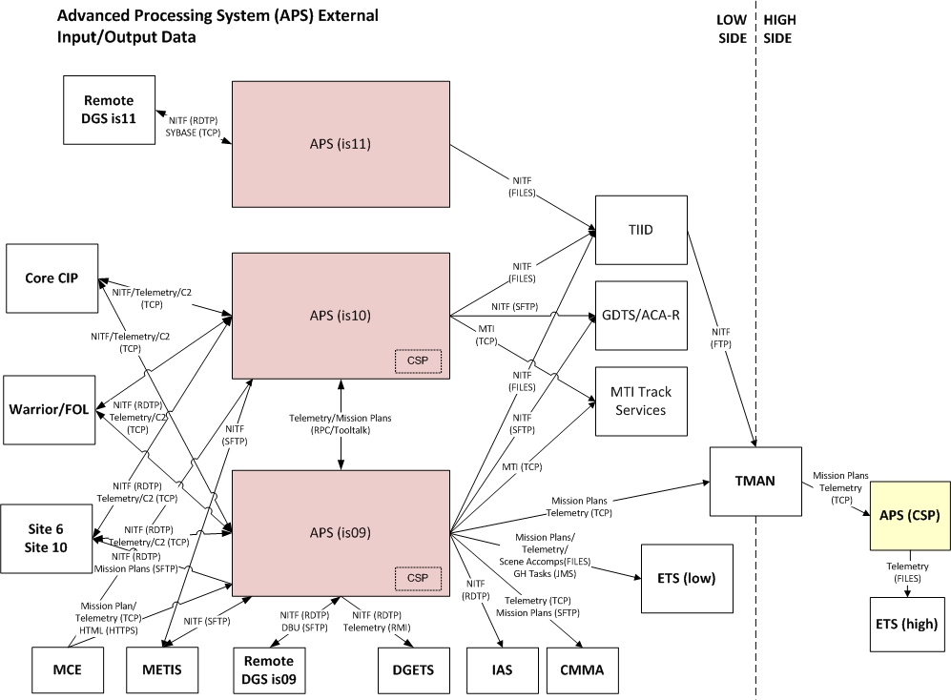
Figure 7 APS+ External Interfaces (To be updated…)

Mission Control Interface (MCI)
The APS+ software Mission Configuration Interface (MCI) application is used to define a mission at a Core or Reach Site. Prior to takeoff, the mission must be defined using the MCI application. Once the mission is defined and started, background processes are launched to provide interfaces for the VIP-C, telemetry, uplink, and other functions, as appropriate.

Sensor Control Workstation (SCWS)
The APS+ software Sensor Control Workstation (SCWS) application connects a DGS to the airborne system via datalink. The SCWS application displays information sent from the airborne system to the DGS and provides an interface to uplink commands from the DGS to the airborne system. Prior to takeoff, the mission must be defined and started using the MCI application, then the DGS to airborne system datalink must be established using the SCWS application.

Common Sensor Planner (CSP)
The APS+ software Common Sensor Planner (CSP) application is the interface to load the mission plan into the ASARS-2A sensor. During a mission, the CSP application can function as a Controlling CSP or as a non- controlling Monitoring CSP.
The Controlling CSP function is used exclusively by the MP during pre-mission planning and during the execution of the mission. During the mission, it is used to modify the mission plan, uplink the mission plan to the sensor, update the database for completion of scenes, and output scene status and mission plan information to the External Tasking Service (ETS). Only one instance of the Controlling CSP function is run for a mission thread during a mission.
The Monitoring CSP function is used by DGS personnel other than the MP during a mission to maintain situational awareness of the mission. The Monitoring CSP function does not output data to databases and external recipients. Multiple instances of the Monitoring CSP function can operate simultaneously.

APS+ Concept of Operations
APS+ CONOPS summary to be provided…

Pre-Mission Operation
To be provided…

Live Mission Operation
To be provided…

Off-Tether Operation
To be provided…

END OF SECTION

OPERATOR INSTRUCTIONS
At DGS sites, operators plan navigational routes which the U-2 aircraft will follow. From these routes, operators may plan and identify potential targets for imagery, and plan a scene to capture the imagery of that target using one of the ASARS-2A modes.

MCI Operator Instructions
This subsection provides MCI displays and controls information, MCI startup and shutdown procedures, MCI functional procedures, and mission thread operation procedures.

MCI Displays and Controls
MCI, SCWS, and CSP Displays and Controls subsections to be developed using the following as a guide…
- Main GUI window description
  - Panel #1 (major section of the main GUI window) description
    - MCI example: exploitation segment
    - CSP examples: map area, toolbar, DP area, etc.
    - SCWS examples: overview imagery area, CBIT area, annotation area, etc.
  - Functionality and visual elements description
    - What it does
    - When it is used
    - Why it is used
    - How it relates to mission
  - Panel #2
  - Panel #N
Controls
- Menu bar
  - Category #1, option #1
    - Describe result of option:
      - Display a new window
      - Load or save a file
      - Toggle a setting, etc.
    - If a new window is displayed:
      - Depict the window
      - Describe its function
      - Describe all controls and displays within the window
      - Describe how to dismiss the window:
        - Close window and apply changes
        - Cancel without making changes
        - Is the window modal (must be dismissed before doing anything else) or can it be left open (“floated”) when returning to the main UI?
    - If the menu bar option leads to a sub-menu (another menu pops out of the menu bar option drop-down when the option is hovered over), describe the sub-options
  - Category #1, option #2
  - Category #1, option #N
- Control widgets (buttons, drop-downs, etc. if any embedded within panel)
- Mouse and keyboard controls
  - Left-click
    - Single click
    - Double click
    - Click and hold
    - Click and drag
    - Modifier key + click
  - Middle-click
  - Right-click
  - Keyboard shortcuts
Standard Control Descriptions
- Type of control: radio button, check box, drop-down, combo box, slider, etc.
- Units (if not obvious from the label)
- Default and/or recommended value
- Range of values: min/max, enumerations, etc.
- If applicable, keyboard shortcuts or modifier keys which apply
- If applicable, whether the control can be customized in some way.

MCI Startup and Shutdown

MCI Startup
During pre-flight, on the DGS MP workstation, perform the following MCI startup steps.

 | Action | Result
 | Log into the workstation  Click Launch at bottom left corner of workstation | 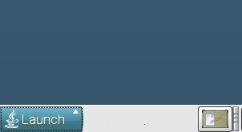  Figure 8 Launch Button
Select Application |  | 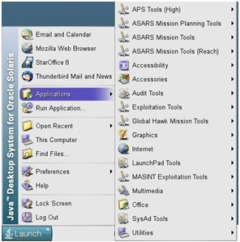  Figure 9 Applications Menu
For Reach Site  ASARS Mission Tools →  Mission Configuration Interface (MCI) |  | 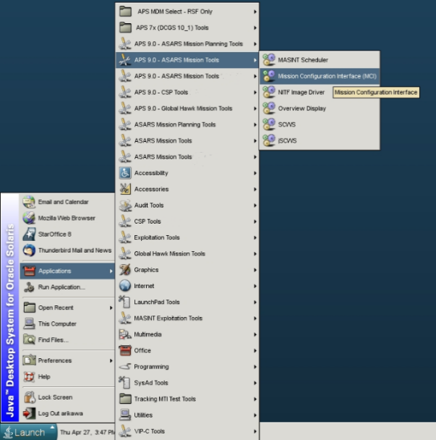  Figure 10 Mission Configuration Interface
Mission Configuration Interface window appears.  Click Start New. |  | 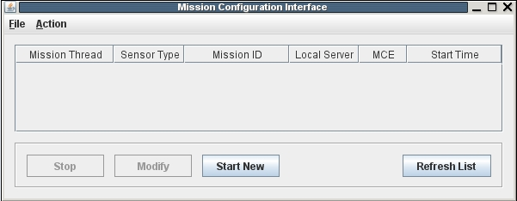  Figure 11 Mission Configuration - Start New
The Start Mission window appears. For ASARS-2A  - Select pulldown Sensor Type : ASARS-2A  - Enter Mission ID  - Select pulldown option for Local Server  - Select pulldown option for Mission Thread  - Pulldown option MCE (Mission Control Element) is disabled – only selectable if selected Sensor Type is ‘Global Hawk’ |  | 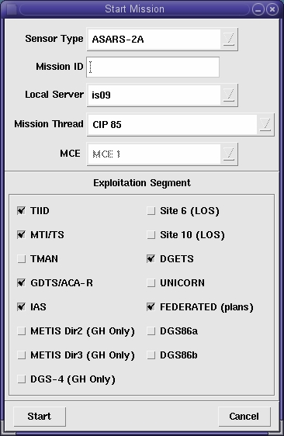  Figure 12 ASARS-2A - Start Mission
Select Exploitation Segment(s) using check boxes  Click Start to start the mission as defined |  | 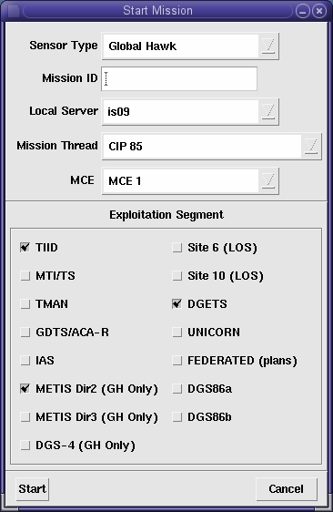  Figure 13 ASARS-2A - Start Mission (To be updated…)
The started mission will display in the Mission Configuration Interface window. Background processes will be started on the Local Server to receive data and provide external interfaces.
For Core Site Mission Status display |  | 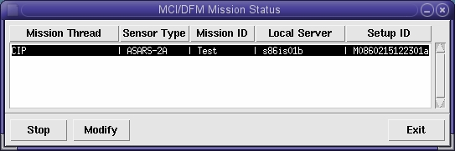  Figure 14 Core Site - Mission Status
For Reach Site Mission Status display |  | 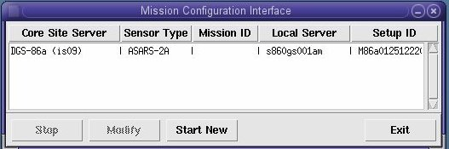  Figure 15 Reach Site - Mission Status

MCI Shutdown
On the DGS MP workstation, perform the following MCI shutdown steps.
Action | Result
To be provided…

MCI Operation

MCI Core Site Options
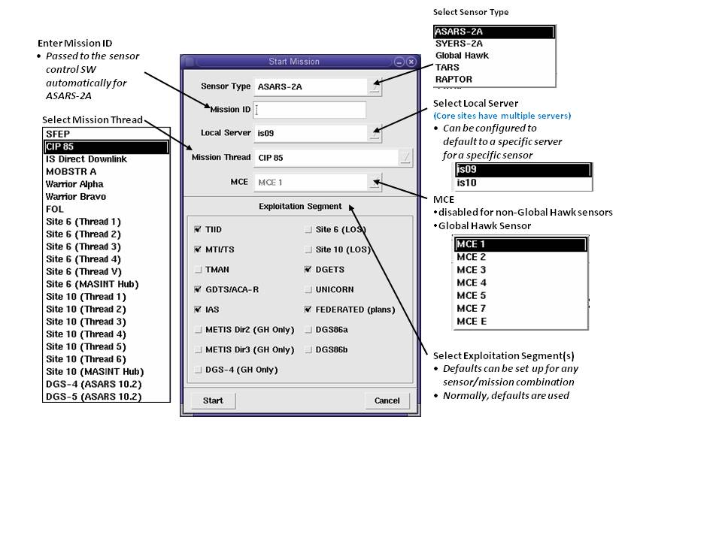
Figure 16 MCI Operation - Core Site

Exploitation Segment Options. The Exploitation Segment check boxes specify where to send data. In most cases, "data" refers to imagery files. However, in a few cases, “data” also mean mission planning data, telemetry data, and/or status files.

The following are the Exploitation Segment check box options on the "Start Mission" window. The description of each option details the type of data that is sent.

Note
This list in the GUI is configurable per site. Each site may have a different list of check box options displayed in this GUI.

Table 4 Exploitation Segment Options (To be updated…)
TIID | Tactical Image ID software | sends imagery mosaics  to the ingest directory for TIID application,  which then fills in the tactical image ID in the NITF header and forwards the NITF file to the TMAN
MTI/TS | MTI Track Services application | sends MTI NITF files  to MTI/TS via a TCP/IP socket connection
TMAN | Trusted Manager | deposits imagery directly into a directory on the TMAN for passing to the high-side security enclave
GDTS/ACA-R | GEOINT Data Transformation Service/Airborne Communication Architecture | sends imagery mosaics  to GDTS/ACA-R using SFTP
IAS | Imagery Access Solutions | sends imagery mosaics  to the IAS system using RDTP
Site 6  (LOS) |  | sends NITF tiles to Site 6 to support Change Detection, only intended for ASARS-2A Reach (LOS) mission
Site 10  (LOS) |  | sends NITF tiles to Site 10 to support Change Detection, only intended for ASARS-2A Reach (LOS) missions
DGETS | DCGS Google Earth Thread Server | sends imagery, telemetry, and  mission plan information  to DGETS for visualization on Google Earth
FEDERATED  (plans) |  | SFTP mission plan information  to other DGSes to support federation
DGS86a |  | send imagery  to DGS-86, Environment A for supporting imagery federation using RDTP
DGS86b |  | send imagery  to DGS-86, Environment B for supporting imagery federation  using RDTP

MCI Reach Site Options
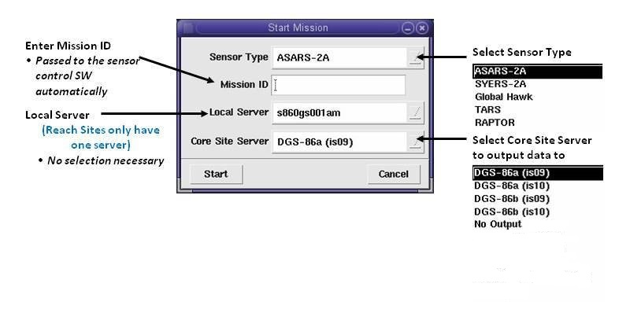
Figure 17 MCI Operation - Reach Site

Mission Thread Operation

Start Mission Thread
On the DGS MP workstation, perform the following Start Mission Thread steps. (To be provided…)

Monitor Mission Thread
On the DGS MP workstation, perform the following Monitor Mission Thread steps. (To be provided…)

Stop Mission Thread
On the DGS MP workstation, perform the following MCI shutdown steps. (To be provided…)

